Synchronicity

**Part A: Synchronizing Clocks**

1. Imagine you have two clocks separated by some distance *L* on a platform. Brainstorm with your group how you might synchronize these two clocks. Provide as many ways as possible.
2. Let’s imagine that we will synchronize the two clocks by using a photoreceptor attached to each clock. Assuming that both clocks are accurate, if we start them at the same time we will know the clocks are synchronized. If we place a light bulb half way between the two clocks with attached photoreceptors, when we turn on the bulb the light will travel the same distance (L/2) and activate the clocks simultaneously. Draw the spacetime diagram illustrating this setup including the clocks and the bulb as well as the light flashes used to synchronize the clocks.

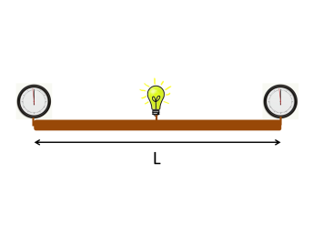

**Part B: Synchronizing Clocks in Motion**

1. Imagine now that we set the platform in motion relative to the ground at a speed that is on the order of the speed of light (i.e. v = 0.5c). Draw the spacetime diagram of the setup this time in the reference frame of a ground observer.
2. Will the ground observer agree that the clocks are synchronized. Why or why not?

**Part C: Time Lag**

1. As viewed from the ground what is the length of the platform? What is the distance separating the bulb from the clocks?
2. The platform is moving to the right: the bulb emits a flash of light. Seen from the ground, the part of the flash moving towards the rear travels at *c*, the rear travels at *v* to meet it. As measured from the ground, express the time it takes the light flash to reach clock A ($t_{A}$) at the back of the platform in terms of the length of the platform and its speed?

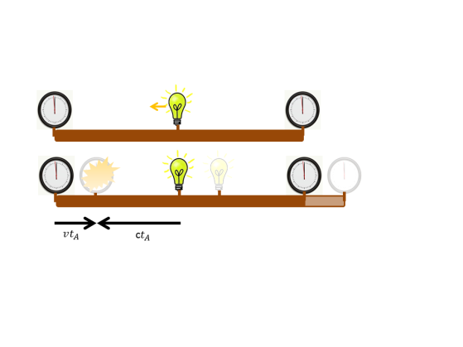

1. The platform is moving to the right: the bulb emits a flash of light. Seen from the ground, the part of the flash moving towards the front travels at *c*, the front travels away from it at *v*. As measured from the ground, express the time it takes the light flash to reach clock B ($t_{B}$) at the front of the platform in terms of the length of the platform and its speed?

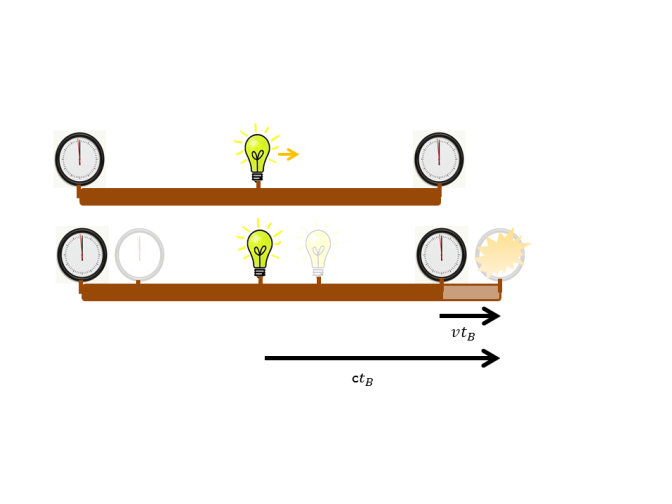

1. For an observer on the ground what is the time difference between the arrival times of the flashes?
2. What will an observer on the ground “see” as the time difference between the two moving clocks. Is it the same or different as d)? Why?

**Putting It All Together**

Review the work that you have done as a group and discuss any points that need clarification.

Summarize the concepts in your notebook. Be sure to address the following points:

- Why does the observer on the ground disagree with the observer on the platform about synchronization of the clocks?

- What if the clocks were located at the exact same spot on the platform would the observers still disagree? Why?

- Does the lack of agreement in synchronizing clocks shown here also explain why we hear thunder before we see lightning? Why?